Physics of Climate Exercise 1

Jakob Schöll, Livia Eichmeyer, Florian Dznoff, Simeon Kraus

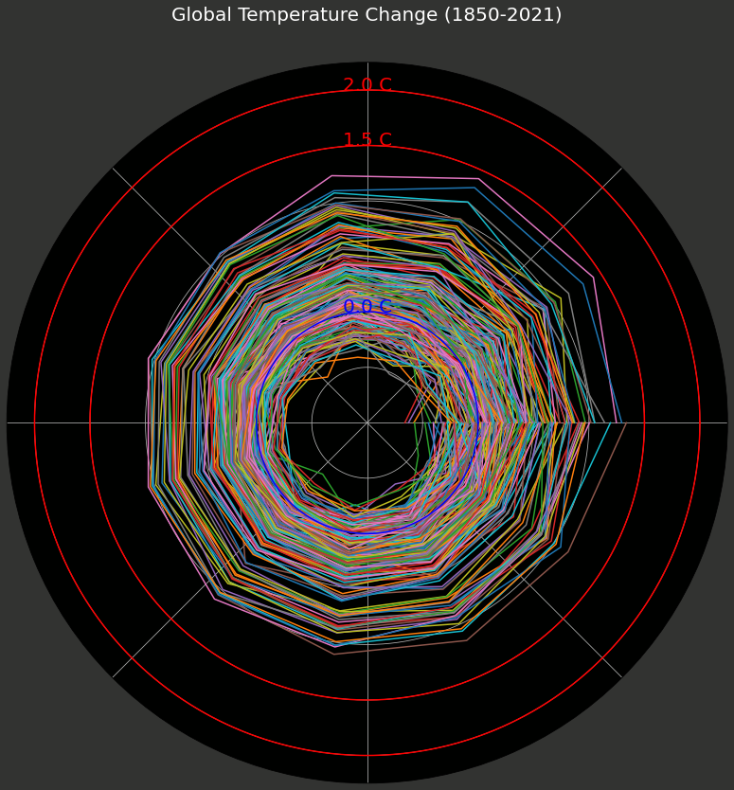

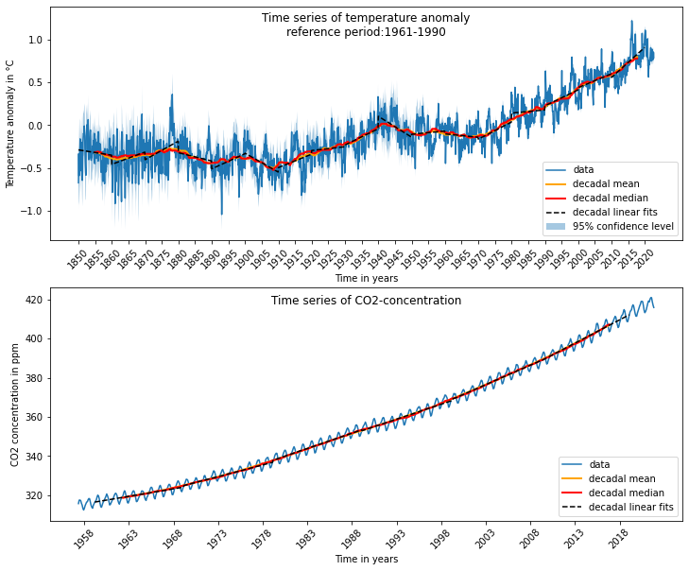

Annual grow rate of temperature in the decades

(obtained from decadal linear fits)

1850s: -0.006184 ppm/yr

1860s: 0.014405 ppm/yr

1870s: 0.021828 ppm/yr

1880s: -0.009696 ppm/yr

1890s: 0.017780 ppm/yr

1900s: -0.022225 ppm/yr

1910s: 0.015747 ppm/yr

1920s: 0.004409 ppm/yr

1930s: 0.019005 ppm/yr

1940s: -0.024541 ppm/yr

1950s: 0.003742 ppm/yr

1960s: -0.003890 ppm/yr

1970s: 0.020147 ppm/yr

1980s: 0.003682 ppm/yr

1990s: 0.018816 ppm/yr

2000s: 0.016271 ppm/yr

2010s: 0.035353 ppm/yr

Annual grow rate of CO2 concentration in the decades

(obtained from decadal linear fits)

1960s: 0.767081 °C/yr

1970s: 1.192464 °C/yr

1980s: 1.559946 °C/yr

1990s: 1.525992 °C/yr

2000s: 1.989682 °C/yr

2010s: 2.378256 °C/yr

Temperature prediction for year 2050: 1.5 °C higher than average 1961-1990

(using quadratic fit for the data from 1970 on)

The growth rates of both temperature and CO2 are generally increasing with time:

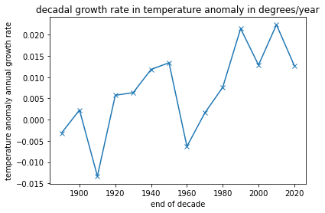

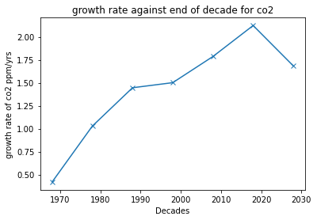

Thermodynamic equilibrium of Earth Surface Atmosphere – as both temperature and CO2 are growing at increasing rates, thermodynamic equilibrium is shifting to higher mean temperatures. Increase in CO2 will augment greenhouse effect, creating a feedback effect that further increases warming.

E_a changes – emissivity of atmosphere increases due to more trapping.

Code:

#!/usr/bin/env python

# coding: utf-8

# In[9]:

import matplotlib.pyplot as plt

import numpy as np

from scipy.optimize import curve_fit

import pandas as pd

# In[3]:

def linear(x, a, b):

return a*x + b

def quadratic(x,a,b,c):

return a*x**2 + b*x + c

# # Data analysis

# In[5]:

#Load temperature data

t_mean, t_low_conf, t_up_conf = np.loadtxt("HadCRUT.5.0.1.0.analysis.summary_series.global.monthly.csv",

unpack=True, delimiter=",", skiprows=1, usecols=(1,2,3))

t_date = np.loadtxt("HadCRUT.5.0.1.0.analysis.summary_series.global.monthly.csv",

unpack=True, delimiter=",", skiprows=1, usecols=0, dtype=str)

#Unpack datestring

t_year = np.array([])

t_month = np.array([])

for timestr in t_date:

t_year = np.append(t_year, int(timestr.split("-")[0]))

t_month = np.append(t_month, int(timestr.split("-")[1]))

#Decadal mean and median

t_dec_mean = np.array([])

t_dec_median = np.array([])

for i in range(0, len(t_mean[120:])):

t_dec_mean = np.append(t_dec_mean, np.mean(t_mean[i:120+i]))

t_dec_median = np.append(t_dec_median, np.median(t_mean[i:120+i]))

#Fitting (linear fits of decades)

t_popt_array = np.array([])

t_pcov_array = np.array([])

t_fit = np.array([])

for d in range(185,202): #from 1850s to 2010s

decade = d*10

mask = np.logical_and(t_year>=decade, t_year<(decade+10))

popt, pcov = curve_fit(linear, np.linspace(decade, decade+10, 120, endpoint=False),

t_mean[mask]) #Parameter a is then in °C/year

t_popt_array = np.append(t_popt_array, popt)

t_pcov_array = np.append(t_pcov_array, pcov)

t_fit = np.append(t_fit, linear(np.linspace(decade, decade+10, 120, endpoint=False), *popt))

#Load CO2 data

c_mean = np.loadtxt("co2_mm_mlo.txt", usecols=3)

c_year, c_month = np.loadtxt("co2_mm_mlo.txt", usecols=(0,1), unpack=True, dtype=int)

#Create datestring

c_date = np.array([])

for i in range(0, len(c_mean)):

c_date = np.append(c_date, "{0:4d}-{1:02d}".format(c_year[i], c_month[i]))

#Decadal mean and median

c_dec_mean = np.array([])

c_dec_median = np.array([])

for i in range(0, len(c_mean[120:])):

c_dec_mean = np.append(c_dec_mean, np.mean(c_mean[i:120+i]))

c_dec_median = np.append(c_dec_median, np.median(c_mean[i:120+i]))

#Fitting (linear fits of decades)

c_popt_array = np.array([])

c_pcov_array = np.array([])

c_fit = np.array([])

for d in range(196,202): #from 1960s-2010s

decade = d*10

mask = np.logical_and(c_year>=decade, c_year<decade+10)

popt, pcov = curve_fit(linear, np.linspace(decade, decade+10, 120, endpoint=False),

c_mean[mask]) #Parameter a is then in °C/year

c_popt_array = np.append(c_popt_array, popt)

c_pcov_array = np.append(c_pcov_array, pcov)

c_fit = np.append(c_fit, linear(np.linspace(decade, decade+10, 120, endpoint=False), *popt))

#Print out grow rates

#Temperature

print("\nAnnual grow rate of temperature in the decades")

print("(obtained from decadal linear fits)")

dec = 1850

for a in t_popt_array[::2]:

print("{0:d}s: {1:9f} ppm/yr".format(dec, a))

dec=dec+10

#CO2

print("\nAnnual grow rate of CO2 concentration in the decades")

print("(obtained from decadal linear fits)")

dec = 1960

for a in c_popt_array[::2]:

print("{0:d}s: {1:9f} °C/yr".format(dec, a))

dec=dec+10

# # Plots

# In[6]:

#Plot

fig = plt.figure(figsize=(12,10))

ax = fig.add_subplot(211)

x = np.linspace(0,len(t_mean), len(t_mean))

ax.set_xticks(x[::60])

ax.set_xticklabels(t_year[::60].astype(int), rotation=45)

ax.plot(x, t_mean, label="data")

ax.fill_between(x, t_up_conf, t_low_conf, alpha=0.4, label="95% confidence level")

ax.plot(x[60:-60], t_dec_mean, linewidth=2, color="orange", label="decadal mean")

ax.plot(x[60:-60], t_dec_median, linewidth=2, color="red", label="decadal median")

#decadal mean/median plotted at time t is mean/median of period (t-5yr, t+5yr)

ax.plot(x[np.logical_and(t_year>=1850, t_year<2020)], t_fit, ls="--", color="black", label="decadal linear fits") #Fits

ax.set_title("Time series of temperature anomaly\nreference period:1961-1990", y=0.85)

ax.set_ylabel("Temperature anomaly in °C")

ax.set_xlabel("Time in years")

ax.legend(loc="lower right")

#Plot

ax2 = fig.add_subplot(212)

x = np.linspace(0,len(c_mean), len(c_mean))

ax2.set_xticks(x[8::60])

ax2.set_xticklabels(c_year[8::60], rotation=45)

ax2.plot(x, c_mean, label="data")

ax2.plot(x[60:-60], c_dec_mean, linewidth=2, color="orange", label="decadal mean")

ax2.plot(x[60:-60], c_dec_median, linewidth=2, color="red", label="decadal median")

#decadal mean/median plotted at time t is mean/median of period (t-5yr, t+5yr)

ax2.plot(x[np.logical_and(c_year>=1960, c_year<2020)], c_fit, ls="--", color="black", label="decadal linear fits") #Fits

ax2.set_title("Time series of CO2-concentration", y=0.9)

ax2.set_ylabel("CO2 concentration in ppm")

ax2.set_xlabel("Time in years")

ax2.legend(loc="lower right")

# Temperature: Decaddal mean (and median) show an increasing trend (since the ~1970s), the slope is becoming steeper.

#

#

# CO2: Decadal mean (and median) of CO2 show an increasing trend

# ### C

# Increasing temperatures imply that a thermodynamic equilibrium does not exist anymore.

# ### D

# In[8]:

#Quadratic Fit to predict 2050

#We do a quadratic fit for all data from 1970 on

#Temperature

mask = t_year >= 1970

t_predict_popt, t_predict_pcov = curve_fit(quadratic, t_year[mask] + t_month[mask]/12, t_mean[mask])

print("\nTemperature prediction for year 2050: {0:0.1f} °C higher than average 1961-1990".format(quadratic(2050, *t_predict_popt)))

print("(using quadratic fit for the data from 1970 on)")

# ### E

# $$T_{s}=(\frac{S_0(1-A)}{2 \sigma})^{\frac{1}{4}}\cdot \frac{1}{(2- \varepsilon_{a})}^{\frac{1}{4}}\\

# \frac{dT_{s}}{d \varepsilon_{a}}= (\frac{S_0(1-A)}{2 \sigma})^{\frac{1}{4}}\cdot \frac{1}{4(2- \varepsilon_{a})^{\frac{5}{4}}}= \frac{1}{4}\cdot \frac{T}{ \varepsilon_{a}}\\

# \Delta T \approx dT,\ \Delta \varepsilon_{a}\approx \varepsilon_{a}\\

# \Rightarrow \frac{ \Delta T}{ \Delta \varepsilon_{a}}=\frac{1}{4}\frac{T}{ \varepsilon}\\

# \Rightarrow \frac{ \Delta T}{T}= \frac{1}{4} \frac{ \Delta \varepsilon_{a}}{ \varepsilon_{a}}

# $$

#

# S doesn't change significantly. A might change because of melting Ice, but this can't be the driving factor. With increasing $CO_2$ levels the emissivity $\epsilon$ increases, which leads to the observed change in temperature.

# In[10]:

#Extra Temperature Graph

hadcrut = pd.read_csv(

"monthlyclimatedata.txt",

delim_whitespace=True,

usecols=[0, 1],

header=None)

hadcrut['year'] = hadcrut.iloc[:, 0].apply(lambda x: x.split("/")[0]).astype(int)

hadcrut['month'] = hadcrut.iloc[:, 0].apply(lambda x: x.split("/")[1]).astype(int)

hadcrut = hadcrut.rename(columns={1: "value"})

hadcrut = hadcrut.iloc[:, 1:]

# In[12]:

hadcrut = hadcrut.set_index(['year', 'month'])

hadcrut -= hadcrut.loc[1850:1900].mean()

hadcrut = hadcrut.reset_index()

# In[13]:

fig = plt.figure(figsize=(14,14))

ax1 = plt.subplot(111, projection='polar')

ax1.axes.get_yaxis().set_ticklabels([])

ax1.axes.get_xaxis().set_ticklabels([])

fig.set_facecolor("#323331")

ax1.set_ylim(0, 3.25)

theta = np.linspace(0, 2*np.pi, 12)

ax1.set_title("Global Temperature Change (1850-2021)", color='white', fontdict={'fontsize': 20})

ax1.set_facecolor('#000100')

years = hadcrut['year'].unique()

for year in years:

r = hadcrut[hadcrut['year'] == year]['value'] + 1

# ax1.text(0,0, str(year), color='white', size=30, ha='center')

ax1.plot(theta, r)

#Temperature rings

full_circle_thetas = np.linspace(0, 2*np.pi, 1000)

blue_line_one_radii = [1.0]*1000

red_line_one_radii = [2.5]*1000

red_line_two_radii = [3.0]*1000

ax1.plot(full_circle_thetas, blue_line_one_radii, c='blue')

ax1.plot(full_circle_thetas, red_line_one_radii, c='red')

ax1.plot(full_circle_thetas, red_line_two_radii, c='red')

ax1.text(np.pi/2, 1.0, "0.0 C", color="blue", ha='center', fontdict={'fontsize': 20})

ax1.text(np.pi/2, 2.5, "1.5 C", color="red", ha='center', fontdict={'fontsize': 20})

ax1.text(np.pi/2, 3.0, "2.0 C", color="red", ha='center', fontdict={'fontsize': 20})

# In[ ]: